

**3**

# Group ideas

Take turns sharing your ideas while clustering similar or related notes as you go. In the last 10 minutes, give each cluster a sentence-like label. If a cluster is bigger than six sticky notes, try and see if you and break it up into smaller sub-groups.

**20 minutes**

focus of your brainstorm.

**minutes**

**5 minutes**

**Team gathering**

efine who should participate in the session and send an **PROBLEM**

nvite. Share relevant information or pre-work ahead. **How might we [your problem statement]?**

**et the goal**

hink about the problem you'll be focusing on solving in he brainstorming session.

**Learn how to use the facilitation tools**

se the Facilitation Superpowers to run a happy and roductive session.

[**Open article**](https://support.mural.co/en/articles/2113740-facilitation-superpowers)

**Key rules of brainstorming**

To run an smooth and productive session

Stay in topic. Encourage wild ideas.

Defer judgment. Listen to others.

Go for volume. If possible, be visual.

## This is a title...

With this motivation, a smart IoT device for child safety and tracking is developed to help the parents to locate and monitor their children. The system is developed using LinkIt ONE board programmed in embedded C and interfaced with temperature, heartbeat, touch sensors and also GPS, GSM & digital camera modules

**Prioritize**

# 4

**Prioritize**

Your team should all be on the same page about what's important moving forward. Place your ideas on this grid to determine which ideas are important and which are feasible.

**20 minutes**

**TIP**

Add customizable tags to sticky notes to make it easier to find, browse, organize, and categorize important ideas as themes within your mural.

# After you collaborate

You can export the mural as an image or pdf to share with members of your company who might find it helpful.

# Quick add-ons

1. **Share the mural**

**Share a view link** to the mural with stakeholders to keep them in the loop about the outcomes of the session.

promoting school safety on open space for kids to learn and explor many new things

any change there safety is not meet,children are at constant risk and may stop showing up

1. **Export the mural**

Export a copy of the mural as a PNG or PDF to attach to emails, include in slides, or save in your drive.

# Keep moving forward

with this motivation,a smart iot device for child safety

safety at school allows children to look forward to being in an encouraging environment promoting social and creative learning

|  |  |  |
| --- | --- | --- |
| child safety monitoring currunt probleam | notifacation alter | child safety every  room wasting some probleam |
| this devics cannot rural Area | to impeance of device which ensures  Network probleam | not completed solution for child safety |
| the battery life longer time device | communication notifacation device |

|  |  |
| --- | --- |
| The android application uses GPS and telephony services to locate their child’s location. | angel child monitoring |
| high | thermal |
| resulation of | vision cam |
| camera will | will be work |
| be placed | on it |

tracking is developed to help the parents to locate and monitor their children

**Importance**

If each of these tasks could get done without any difficulty or cost, which would have the most positive impact?

child safety for gadgets communication for parents

smart phone monitoring and notifications

the system is developed using linkit ONE board programmed in embedded c

**Strategy blueprint**

Define the components of a new idea or strategy.

[**Open the template**](https://app.mural.co/template/e95f612a-f72a-4772-bc48-545aaa04e0c9/984865a6-0a96-4472-a48d-47639307b3ca)

social safety creates a trusting and safe atmosphere for children to try out there skills,to fail and try again

**Customer experience journey map**

Understand customer needs, motivations, and obstacles for an experience.

[**Open the template**](https://app.mural.co/template/b7114010-3a67-4d63-a51d-6f2cedc9633f/c1b465ab-57af-4624-8faf-ebb312edc0eb)

**Strengths, weaknesses, opportunities & threats**

Identify strengths, weaknesses, opportunities, and threats (SWOT) to develop a plan.

it also provides an opportunity,to determine whether a childs development is on track

|  |  |
| --- | --- |
|  |  |
|  |  |

[**Open the template**](https://app.mural.co/template/6a062671-89ee-4b76-9409-2603d8b098be/ca270343-1d54-4952-9d8c-fbc303ffd0f2)

**TIP**

Participants can use their cursors to point at where sticky notes should go on the grid. The facilitator can confirm the spot by using the laser pointer holding the **H key** on the keyboard.

[**Share template feedback**](https://muralco.typeform.com/to/CiqaHVat?typeform-source=app.mural.co)

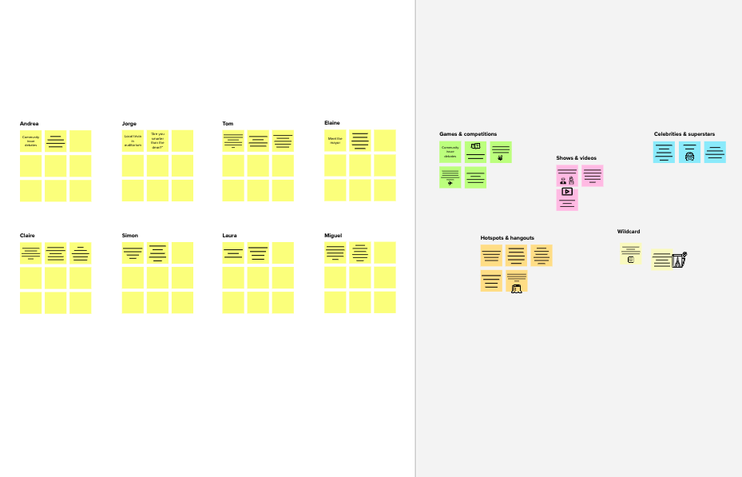

**Before you collaborate**

A little bit of preparation goes a long way with this session. Here’s what you need to do to get going.

**10**

**1**

**Define your problem statement**

What problem are you trying to solve? Frame your problem as a How Might We statement. This will be the

**Brainstorm**

**& idea prioritization**

Use this template in your own brainstorming sessions so your team can unleash their imagination and start shaping concepts even if you're not sitting in the same room.

**2**

**Brainstorm**

Write down any ideas that come to mind that address your problem statement.

**A**

**10 minutes**

D

i

**B S**

T

t

**C**

**Person 1**

**Person 2**

**Person 3**

**Person 4**

U

p

the child safety

SOS light along with

we can

More family

wearable device it provides parents distress alarm buzzer

can act as a smart with the real time for their child's

device

**10 minutes** to prepare

**1 hour** to collaborate

**2-8 people** recommended

location,surrounding surrounding and the temperature ability to locate their

child or alert

automatically uses of satellite spend there for

monitor the communication work and social

child using GPS,GSM.

in devices. duties but since children or gift

the system the child location

the current

their child or alert

To track and

provides a outdoors by

situation of out Absence of child

country is not monitoring system, get exact

acting to rescue or for the parent to allows then to

bystanders in tracking solution using GPS as it

forgetable for it is hard monitor location of

comfort the child

keep tracking determine

monitoring chlidren about of children in school

children

minimize this the exact UNICEF standard

help to

they whole

It increase the always keep

tragedy to location of indicated for

interaction of

day

reoccur in the the child it child labour

family with the information

future

there for includes the

mothion sensors will be use

24x7 will be use

following

children

about children

the doors closed in monitoring

Embedded C and interface with temperature, hearbeat and also GPS

[**Share template feedback**](https://muralco.typeform.com/to/CiqaHVat?typeform-source=app.mural.co)

**Need some inspiration?**

See a finished version of this template to kickstart your work.

[**Open example**](https://app.mural.co/template/e5a93b7b-49f2-48c9-afd7-a635d860eba6/93f1b98d-b2d2-4695-8e85-7e9c0d2fd9b9)

body temperage probelam

child monitoring devices

some probleams for child

This is physically not possible so we introduce Safety Monitoring system

**TIP**

You can select a sticky note and hit the pencil [switch to sketch] icon to start drawing!



**Template**

# Feasibility

interfaced with tenperature,hearbeat,touch sensor also GPS,GSM

Regardless of their importance, which tasks are more feasible than others? (Cost, time, effort, complexity, etc.)